EXPERIMENT NO. 13
CYCLOMATIC COMPLEXITY OF A FLOW GRAPH
AIM
To find the cyclomatic complexity of a program whose flow graph has 17 edges, 13 nodes and 5 predicate nodes, and to verify the result using the alternate formula.
SOFTWARE / TOOLS REQUIRED
- RAPTOR / any drawing tool for the control flow graph
- Calculator
PROCEDURE
Step 1: Read the Problem Statement
- Read the given control flow graph details carefully.
- Identify the values provided for the number of edges, nodes, and predicate nodes.
- Note the given values:
- Number of Edges (E) = 17
- Number of Nodes (N) = 13
- Number of Predicate Nodes (P) = 5
Step 2: Draw the Control Flow Graph
- Draw the control flow graph representing the program.
- Label all the nodes and edges correctly.
- Identify the predicate (decision) nodes in the graph.
Step 3: Count the Graph Components
- Count the total number of nodes in the control flow graph.
- Count the total number of edges connecting the nodes.
- Count the number of predicate nodes present in the graph.
- Verify that the counted values match the given data.
Step 4: Apply the Cyclomatic Complexity Formula
- Use the Cyclomatic Complexity formula:
- V(G) = E − N + 2
- Substitute the given values:
- V(G) = 17 − 13 + 2
Step 5: Calculate the Cyclomatic Complexity
- Perform the calculation:
- V(G) = 6
- Record the calculated Cyclomatic Complexity value.
Step 6: Verify Using Predicate Nodes
- Use the alternate formula:
- V(G) = P + 1
- Substitute the given value:
- V(G) = 5 + 1
- Calculate the result:
- V(G) = 6
- Compare the result with the previous calculation.
Step 7: Analyze the Result
- Verify that both methods produce the same Cyclomatic Complexity.
- Conclude that the program contains six independent execution paths.
Step 8: Interpret the Complexity
- Determine the testing effort required based on the Cyclomatic Complexity value.
- Note that a Cyclomatic Complexity of 6 indicates a program with moderate complexity and
- at least six independent test cases are required for complete basis path testing.
Step 9: Document the Result
- Record all calculations neatly.
- Write the final Cyclomatic Complexity value in the observation section.
Step 10: Save the Work
- Verify the calculations once again.
- Save the document or record the experiment for submission.

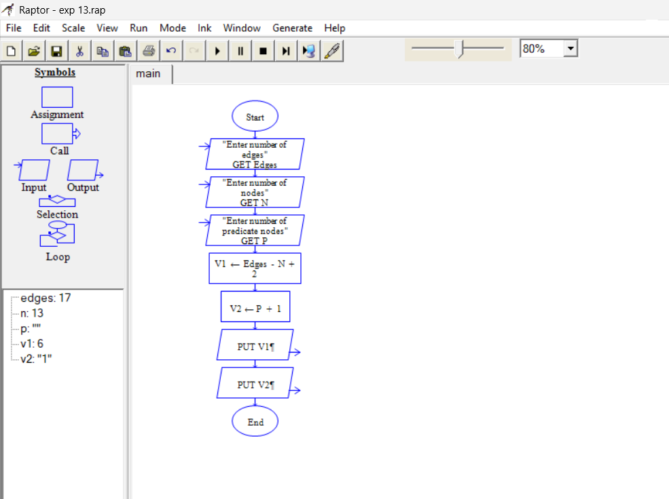
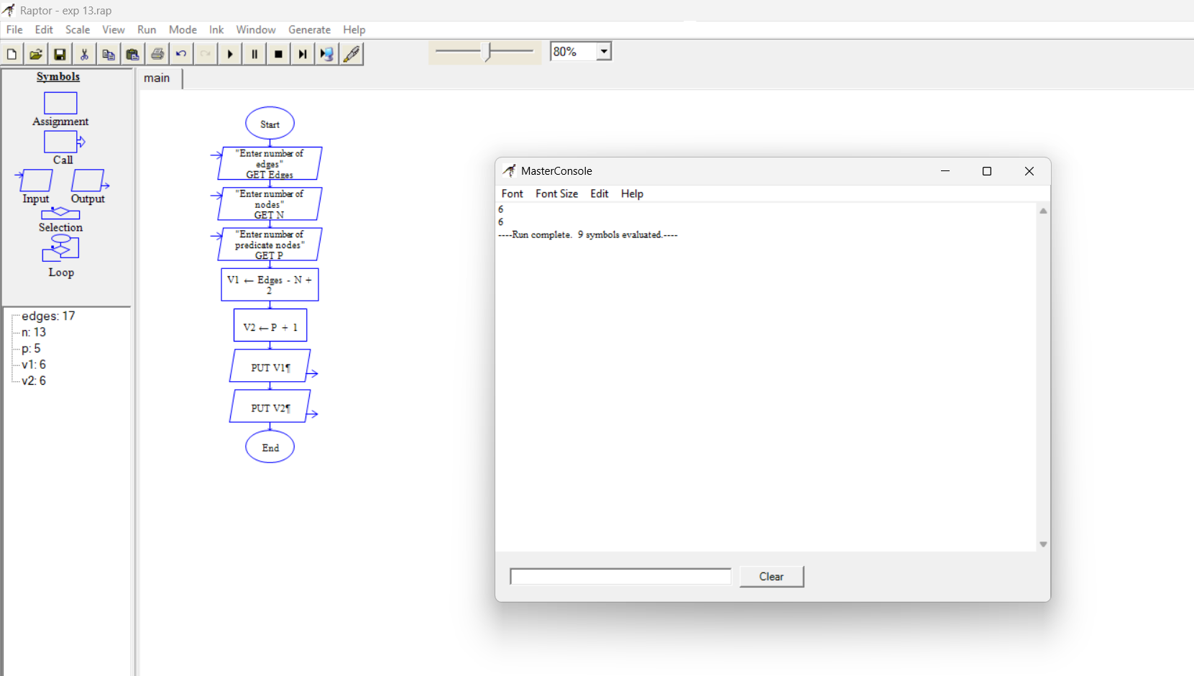

EXPECTED OUTPUT
- Using V(G) = E − N + 2 = 17 − 13 + 2 = 6
- Using V(G) = P + 1 = 5 + 1 = 6
- Both methods give V(G) = 6, so at least six independent test paths are required.
RESULT
Thus the cyclomatic complexity of the given flow graph was calculated as V(G) = 6 using both formulae, indicating six independent paths and moderate complexity.

